**ITA0448**

**STATISTICS WITH R PROGRAMMING**

**DAY 1 ASSESSMENT**

**NAME: RISHIKUMAR V**

**REG NO: 192121080**

**1. Write a R program to create a vector of a specified type and length. Create**

**vector of numeric, complex, logical and character types of length 6. Use**

**this vector for Below program**

**x = c(10,30, 20, 20, 25, 9, 26,38,40,60)**

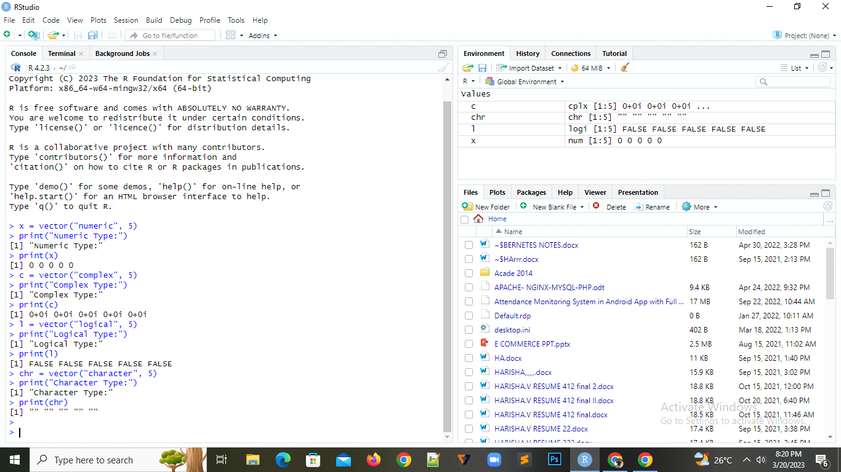

**2. Write a R program to find Sum, Mean and Product of a Vector.**

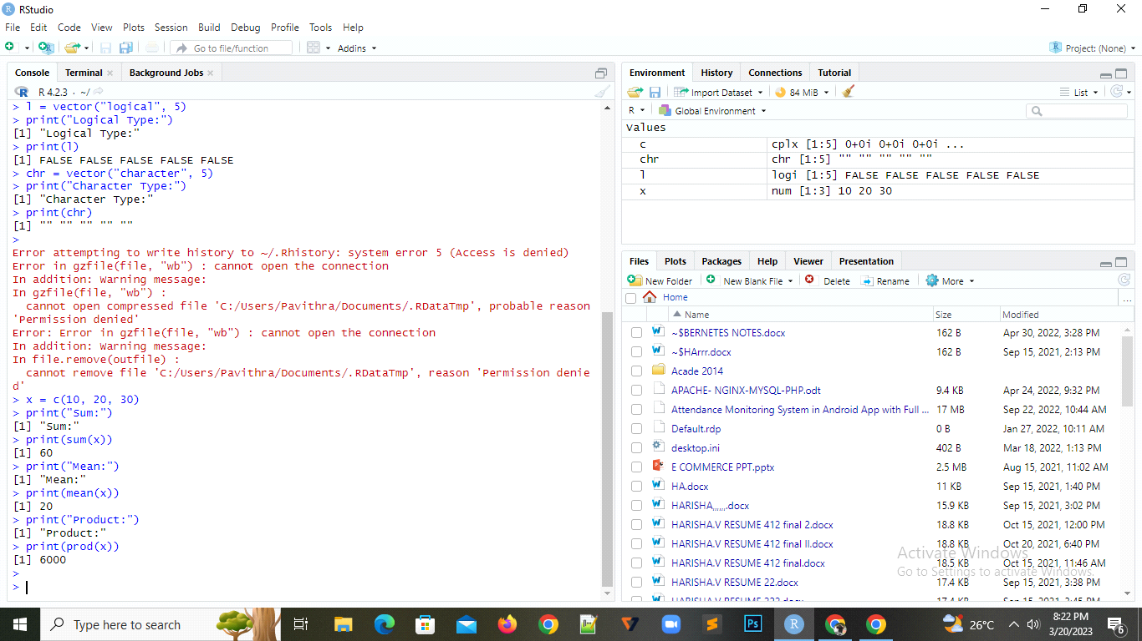

**3. Write a R program to sort a Vector in ascending and descending order.**

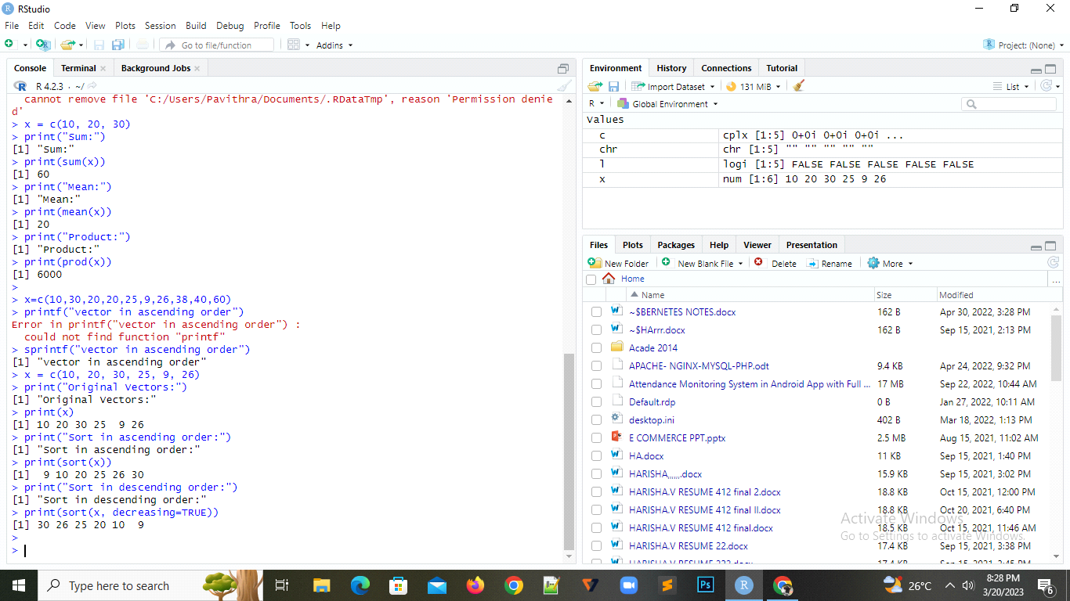

**4. Write A R program to find Fourth highest value in a given vector.**

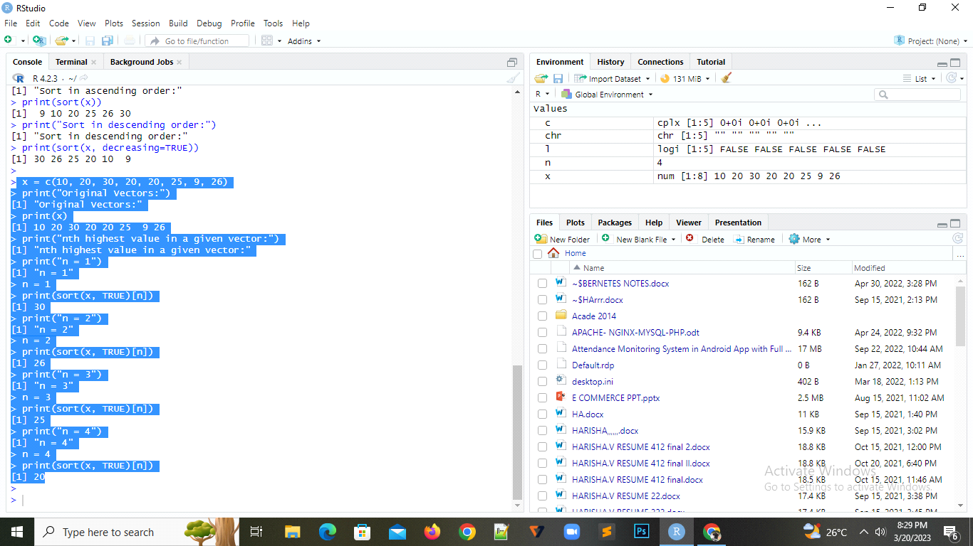

**5. Write a R program to add a new item g4 = &quot;R Prog&quot; to a given list.**

**Sample list: (g1 = 1:20, g2 = &quot;Python&quot;, g3 = &quot;HTML&quot;)**

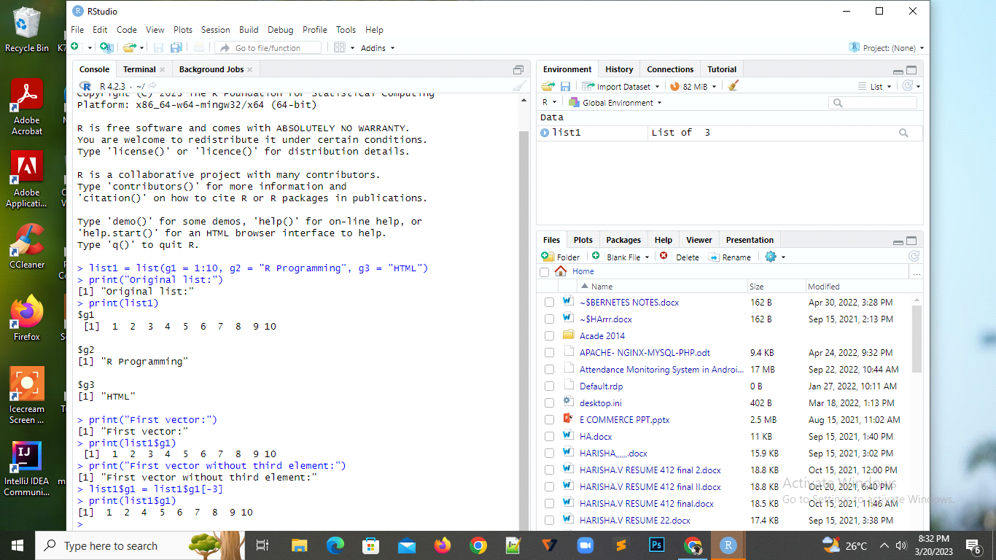

**6. Write a R program to extract all elements except the second element of the**

**first vector of a given list.**

**Sample list: (g1 = 1:20, g2 = &quot; Python &quot;, g3 = &quot;HTML&quot;)**

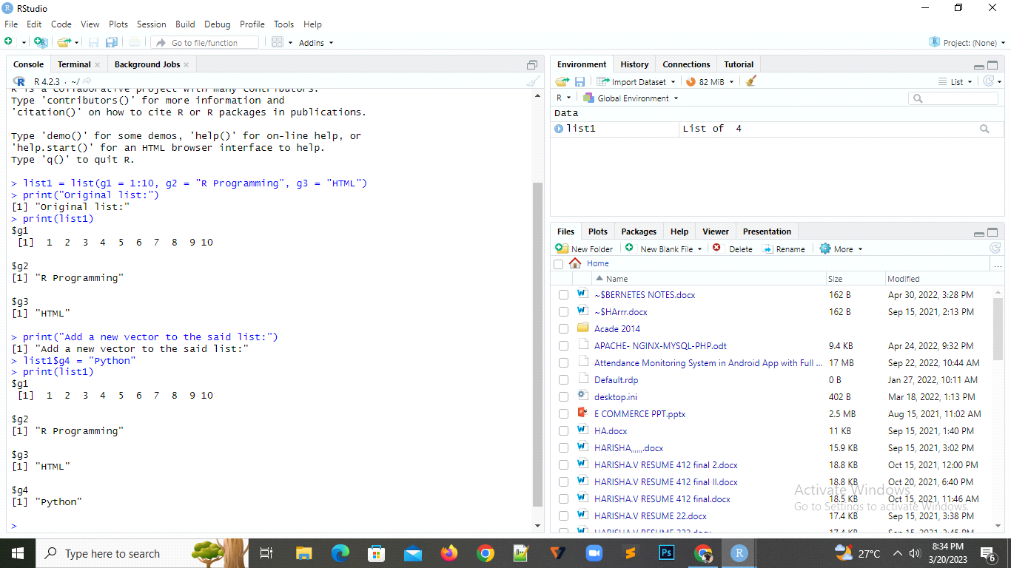

**7. Write a R program to create an ordered factor from data consisting of the**

**names of months**

**mons_v = c(&quot;March&quot;,&quot;April&quot;,&quot;January&quot;,&quot;November&quot;,&quot;January&quot;,**

**&quot;September&quot;,&quot;October&quot;,&quot;September&quot;,&quot;November&quot;,&quot;August&quot;,&quot;February&quot;,**

**&quot;January&quot;,&quot;November&quot;,&quot;November&quot;,&quot;February&quot;,&quot;May&quot;,&quot;August&quot;,&quot;Februa**

**r**

**y&quot;,&quot;July&quot;,&quot;December&quot;,&quot;August&quot;,&quot;August&quot;,&quot;September&quot;,&quot;November&quot;,&quot;Se**

**p tember&quot;,&quot;February&quot;,&quot;April&quot;)**

